Technical Committee 4.3 Earthworks – Working Group 1

Questionnaire on

***Resilience of Earthworks***

*Information about the contact person*

|  |  |
| --- | --- |
| Name |  |
| First name |  |
| Country |  |
| Company Name |  |
| Administration / Service |  |
| Function performed |  |

**Preamble**

The main aim of this questionnaire is to gather information regarding the concept of ‘resilience’ applied to the design, construction and repair of earthworks/earth structures under natural hazards (including those due to climate change) in different countries in order to collect and share information about cases, techniques and practices employed.

As a starting point, some first-tentative definitions of ‘resilience’ are given below, to illustrate that a complete and unambiguous definition does not exist.

1.“*to prepare and plan for, absorb, recover from, and more successfully adapt to adverse events*” - (Disaster Resilience: A National Imperative, National Research Council, 2012);

2.“*to anticipate, prepare for, and adapt to changing conditions and withstand, respond to, and recover rapidly from disruptions* …” - (FHWA Order 5520);

3.“*of the transportation system to recover and regain functionality after major disruption or disaster*.” - (AASHTO);

4.“*the capacity of individuals, communities, institutions, businesses, and systems within a city to survive, adapt, and grow, no matter what kinds of chronic stresses and acute shocks they experience*.” - (100 Resilient Cities).

**Note**

This questionnaire is formed of three parts.

The first part is basic and particularly important: through a few questions it aims to verify the awareness of the concept of resilience in different countries, as applied to geotechnical systems, and requires a preliminary understanding of practices and technical standards.

The second part is more technical, and aims to collect detailed information on cases of application of resilience to earthworks.

The third part is a call for literature documents about resilience applied to earth structures design, construction, repair and maintenance that you know that are available, in any language.

**How to answer**

If you are not able to answer one or more questions, please just complete the survey for the questions you are able to answer. It is possible to answer to a single part of three only.

Please forward this survey to any relevant road operators (concessionaires) and research institutes/laboratories linked to your administration, if any.

* **Part one**

**Question 1**: In your opinion, what does the concept of ‘resilience’ mean when applied to geotechnical assets?

**Question 2:** In your opinion, what are the main features or parameters to describe a resilient geotechnical system?

**Question 3**: In your opinion, what are the possible benefits inferred from the application of a ‘resilient’ design approach to the geotechnical assets?

**Question 4**: Are there standards/best practices in your country that explicitly implement design approaches or technical maintenance strategies to guarantee the resilience of a geotechnical asset?

If so, which ones? (Please, limit your answer to 100 words)

* **Part two**

Considering your previous responses, can you provide well documented case studies of existing earthworks/earth structures in your country affected by natural hazards and successfully repaired/modified after the event? Or, from another point of view, do you know design approaches to make a geotechnical asset more resilient to natural hazards?

Please add remarks, comments and, if any, tables and pictures to better explain situations and repair measures, with a focus on techniques, type of works, delay for the works, quality of works and costs, if available.

Key words for cases review:

*Earthworks, Earth Structures, Failure, Geotechnical System.*

As an example, a case description could be arranged as the follows:

* Description of situation, with a general outlook to geological/geotechnical features of the site:

*… As an example, I can take into account an event occurred in Sardinia in*

*November 2013 when very heavy rain in hours produced massive floodings*

*and heavy damages to roads and earthworks. Tipically, large culverts under embankments were completely scoured and, in some cases, destroyed (see attached picture ...). These culverts had to be replaced with bridges that, hopefully, shall cope with increased water flow in small rivers (see picture ... – site prior to works and afterward)…*

* A general overview of the site, providing geological and geotechnical data, if any.
* Climate classification of the site/area/country (please refer to Koppen-Geiger classification map in annex 1).
* Pictures, drawings, tables able to better specify geometry/nature/main features of earthworks/earth structure(s) involved.





* Tables of materials[1], techniques[2], costs of repair.
* Remarks about type of works[3], delay for the works, quality of works, medium- and long-term behaviour, if known or applicable.

Has the experience of this/these case/s been incorporated into the design of new earth structures?

* **Part three**

Existing references for resilient earth structures (any language). Please add bibliography or full article/s (DOC or PDF).

Key words for literature review:

*Resilience, Earthworks, Earth Structures, Damage, absorb Deformation, Anticipation of Damage, Adaptation to changing Conditions, Recovery and regaining Functionality after Disasters.*

It would be appreciated if you could send this information to Kamel Zaghouani (k.zaghouani@terrasol.com.tn) and Enrico Mittiga (e.mittiga@stradeanas.it) by September 30, 2020 in order to meet deadlines established for this work cycle. Please contact Mr Zaghouani or Mr Mittiga if you have any questions. Thank you in advance for your help!

This work will be highlighted in a synthesis summarizing all the cases collected worldwide, to be published in June 2021. The best studies will be presented at the World Road Congress to be held in Calgary in February 2022.

The lessons learned will be the subject of a public synthesis report which will present best practices in earthworks resilience.

**Annex 1**

**Koppen-Geiger Climate Classification World Map**

This map may be used to localise your case study

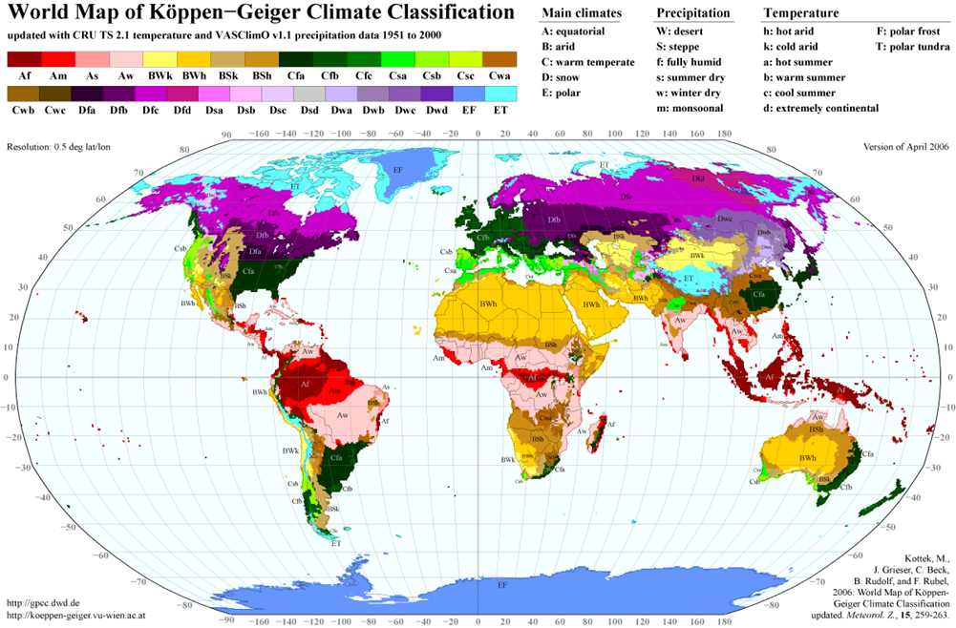

1. Some materials may be considered more resilient than others
2. Some materials may be more adapted than others to complex situations, do not hesitate to comment on the choices that have been made.
3. In some cases, the choice may be made to carry out emergency work, perhaps summary, which must be taken up again later: do not hesitate to detail the different steps.